

Global Protect (VPN)
By: Marvin Boonnantakul

Purpose: The purpose of this lab is to set up Global protect on the palo alto PA-220 to further simulate and test the security of remote access through Global Protect VPN on the firewall. The goal of this setup is to allow one’s user to remotely access another computer through a protected and secure network using the Remote Desktop Connection from the outside computer to access the host computer.

Background Information on lab concepts:
Virtual Private Network, also known as VPN, provides users with the secure connection needed inside a private network when connecting to remote locations over the internet through encrypting traffic. This can be achieved through Globalprotect from Palo Alto’s VPN provides the secure access needed inside the internal resources.
A tool needed to help make this setup happen in this lab is through the PA-220 firewall which acts as a security gateway to control traffic in and out of the network simultaneously enforcing the security policies. This includes authentication, routing, and encrypting for VPN users in this setup.
Lastly, to complete this setup for a remote connection, the desktops require the Remote Desktop Connection protocol allowing users to connect to one another and control another computer remotely through the network. Remote Desktop is made to establish the VPN tunnel to simulate real world remote access in internal systems.
Lab Summary: Using 2 computers that is connected to a PA-220 firewall that is configured with Global Protect VPN the user will be able to connect and sign into the host computer remotely elsewhere. In order to run this setup, the lab requires the firewall to: Assign IP pools for VPN clients, Enable Global Protect portal and gateway, Set up authentication profiles, and Configure security policies allowing VPN traffic to run through. Furthermore, the external computer must install the Global Protect client to connect to the firewall. When connected and received the internal IP address, it will allow it to act as insider to the local network. Lastly the outside computer must run Remote Desktop Connection, to the external user successfully through its IP address or its PC name to successfully access the internal computer through the firewall illustrating the secure remote connectivity.
Problems: Some few problems me and my Lab partner face would be:
-Certification conflicts from previous labs: This occurred due to the configurations and the certificate issues from the URL filtering lab which caused the old certificates to interfere with the Global Protect setup. This was resolved by Resetting and restarting the configurations.
-Incorrect IP address in certificate: Certification did not match the external IP address causing the firewall to not trust and connect to the firewall.
-Firewall security policy blocking traffic: By misconfiguring the security policy the firewall prevents the VPN traffic from accessing the internal network, which blocks the remote desktop connection.
-Incorrect certification export to client machine: By exporting the wrong certificate on to the external PC, it prevents the authentication to properly secure a establish connection.
-Conflicting VPN software: Since the external computer has another VPN running, it interfered with the GlobalProtect causing connection to fail.
-Using hostname instead of IP for remote Desktop: By using the host PC name instead of the IP address the external computer will not be able to connect due to the lack of proper DNS resolution.

Lab Commands: N/A
Configurations:
Firewall Setup (PA-220): Configured GlobalProtect Portal and Gateway, Set authentication profile (local or directory-based), Assigned IP address pool for VPN clients, Enabled SSL/TLS encryption, then Created security policies: Allow VPN traffic from external to internal and allowing RDP between VPN clients and internal hosts.
Client Setup: Installed GlobalProtect client on external computer, Connected using firewall’s public IP, Check the IP assignment from VPN pool.
Remote Desktop Setup: Enabled Remote Desktop on internal computer, Used internal IP address for connection, then logged into the user.
Network Diagram with IP’s: 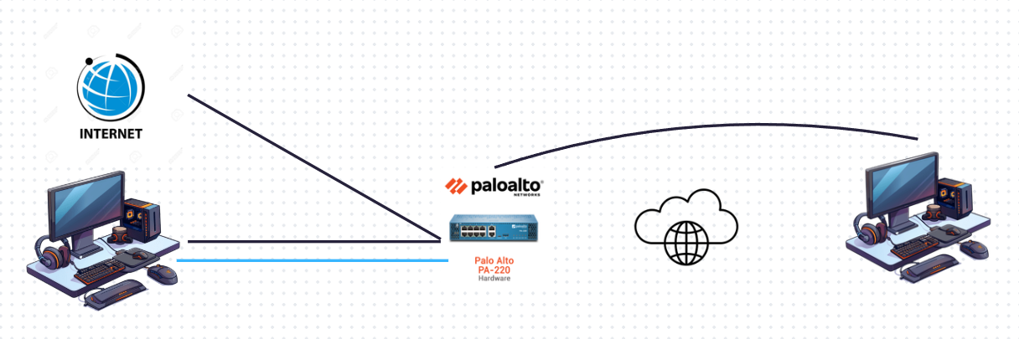
Conclusion: When the lab is successfully setup it will demonstrate the secure remote access through the GlobalProtect VPN from the PA-220 firewall that will connect with the VPN tunnel and the external computer to gain access with the internal system via Remote Desktop Connection. To conclude everything that has been configured and stated so far the lab reveals the importance of thefirewalls authentication and configuration to enable safe remote access and to show real world use through the importance of secure remote network practices
Screenshots:
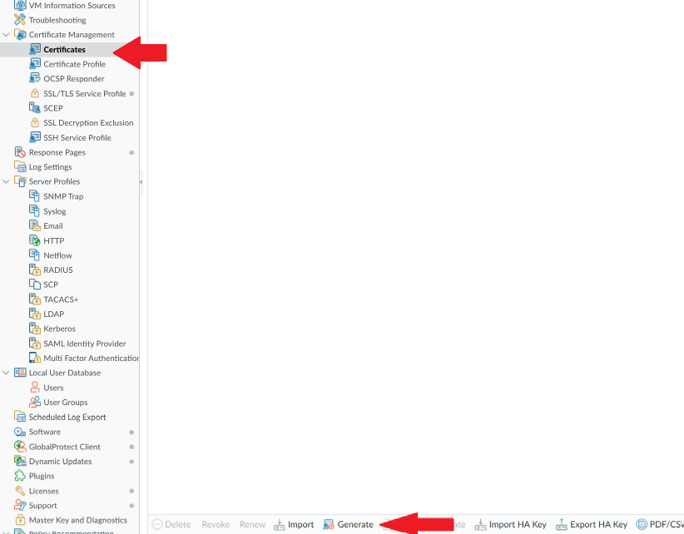First generate, the Root Certificate and make sure to name and assign ip in certificate attributes.
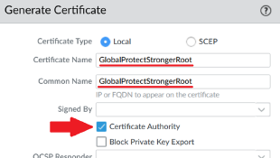
Next, create the server certificate.
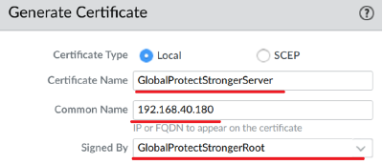
Make sure the common name is the outside facing ip of the firewall. All other tags should match the root server’s.
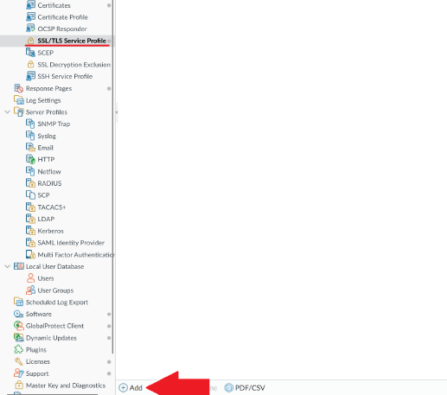
Still in device, create a SSL/TLS profile
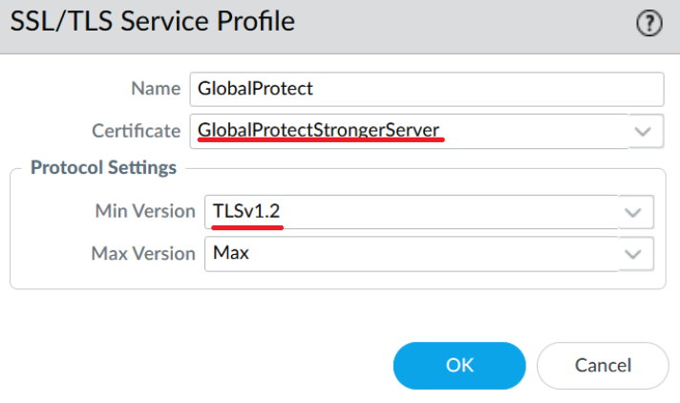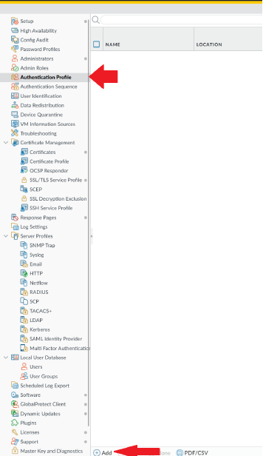
Then add a Authentication profile.
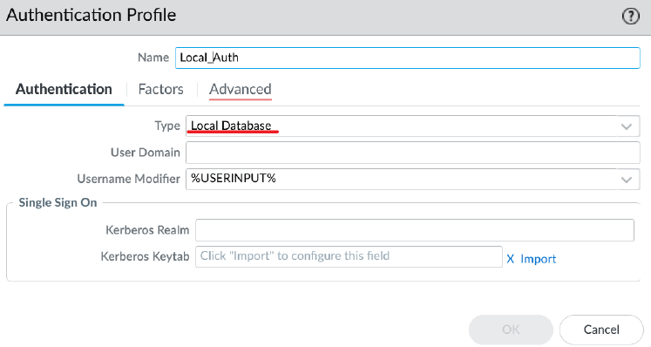
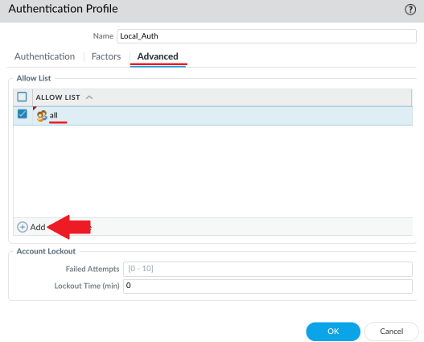
Next, go to network, interfaces, tunnel
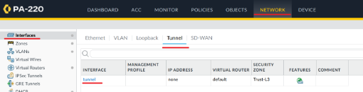
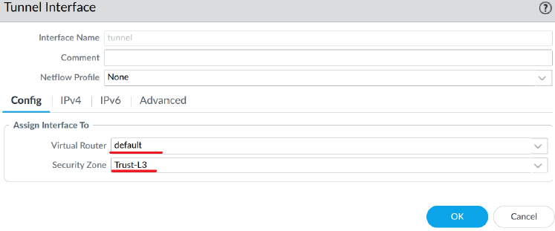
Put it in Trust-L3
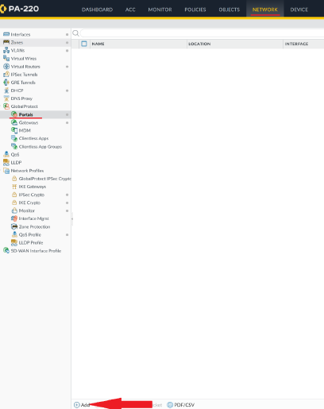
Go to Network, Portals, Add.
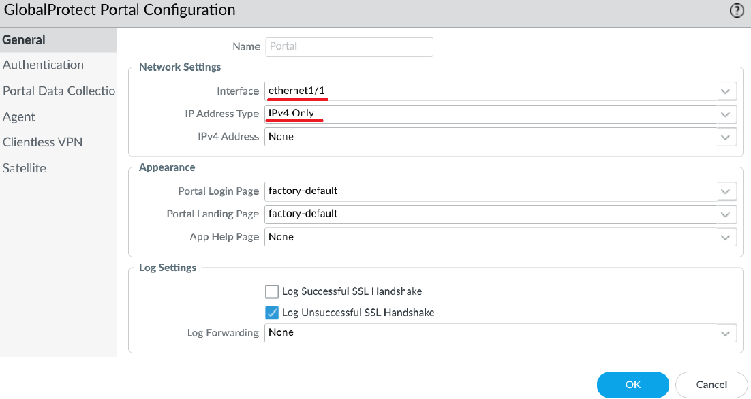
Make sure it’s the port connected to the internet.
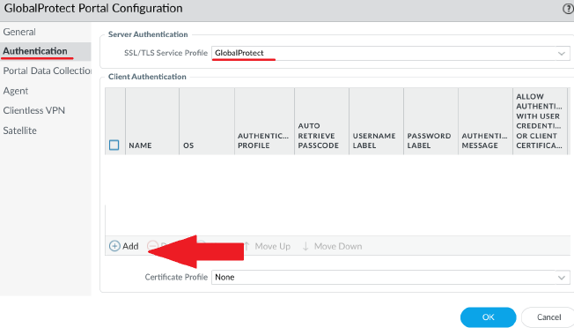
Under authentication, put in the SSL/TLS service profile created, then hit add.
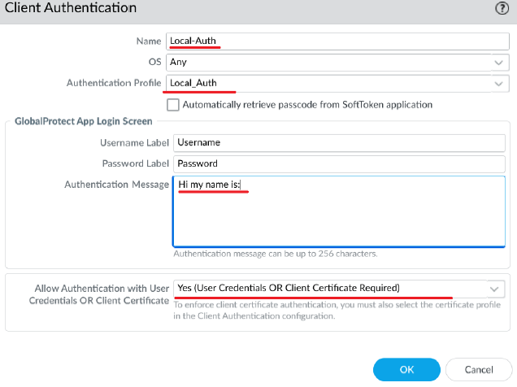
Put in the authentication profile made along with messages of authentication.
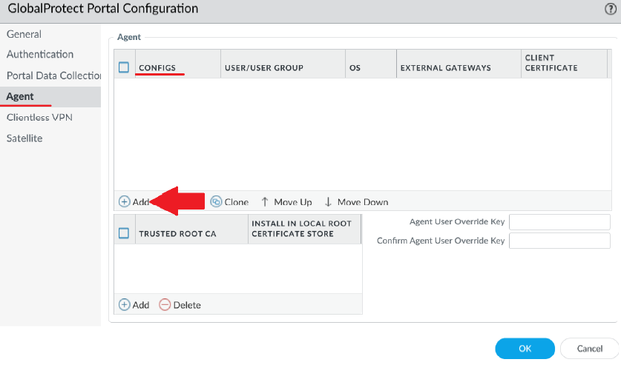
Then under agent, configs, hit add.
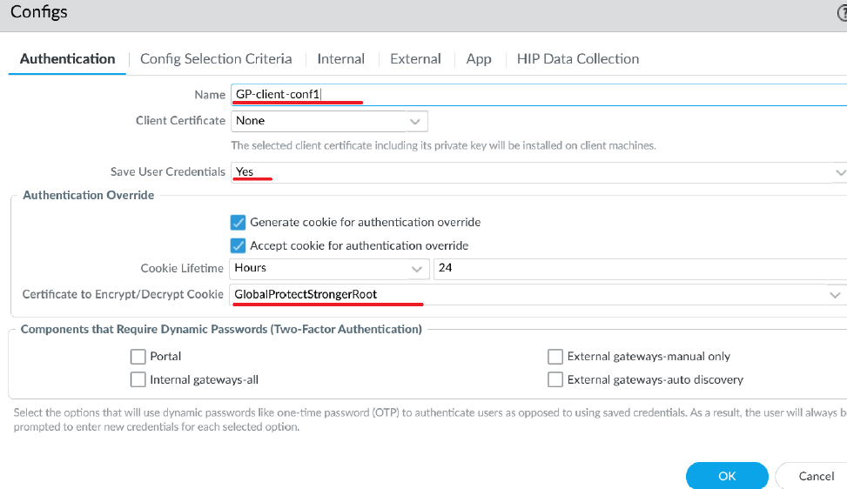
Make sure the override certificate is the root certificate.
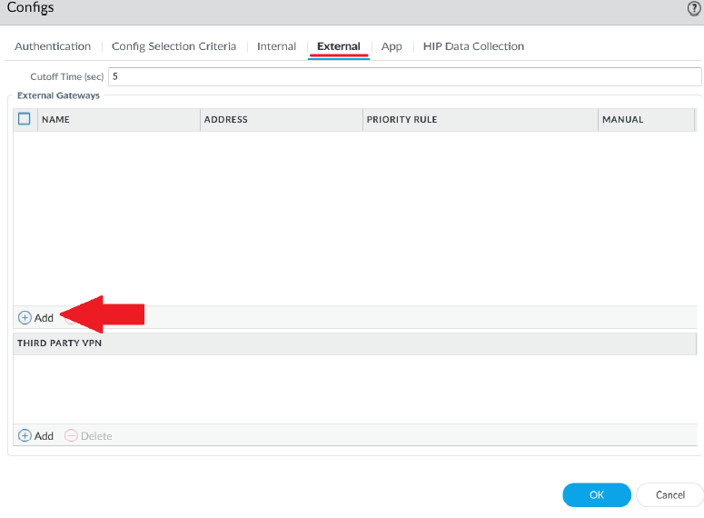
In external hit add
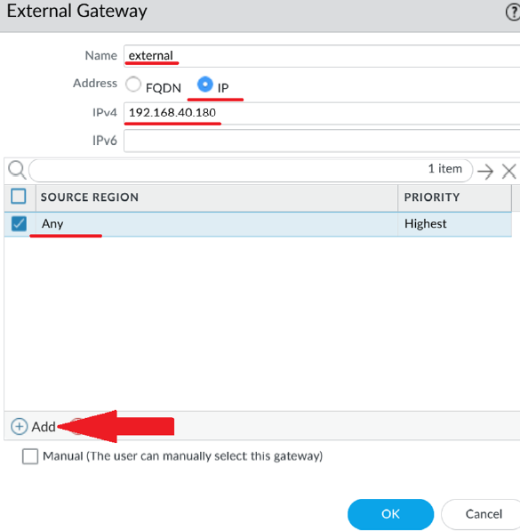
Place the outward facing ip in with source region set to any.
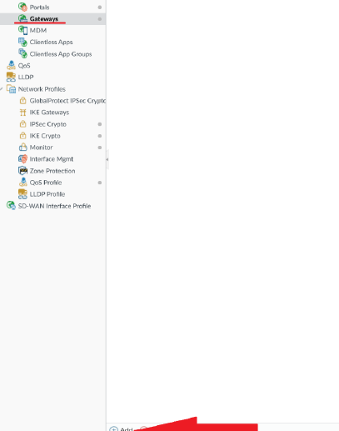
Next go to network, gateways, hit add.
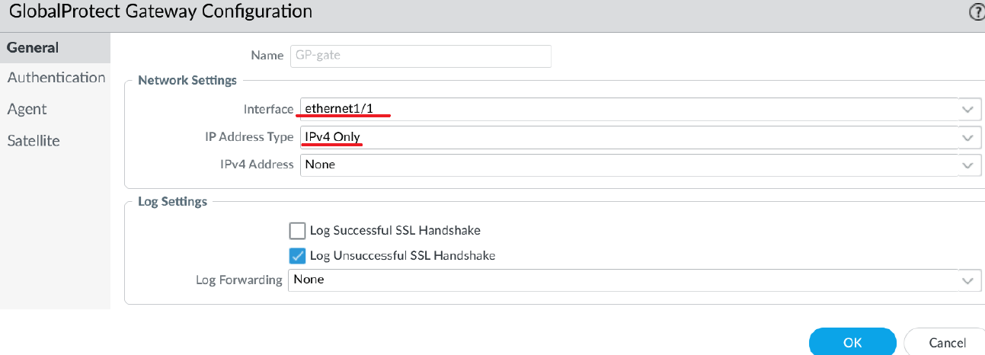
Set ipv4 only and your interface should be your internet facing interface.
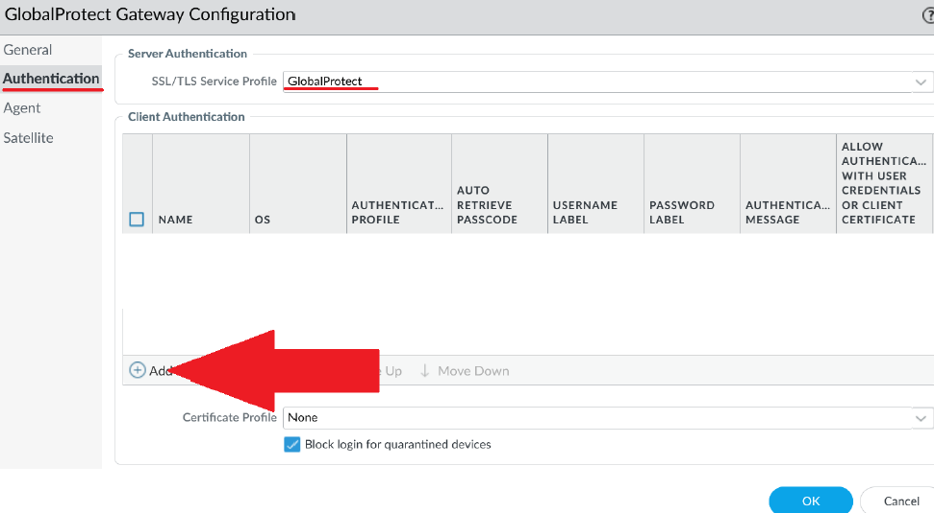
Under authentication put in the SSL/TLS service profile and then hit add in client authentication.
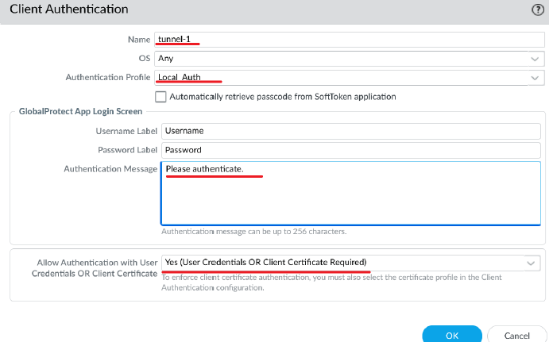
Configure the same or similar messages to before.
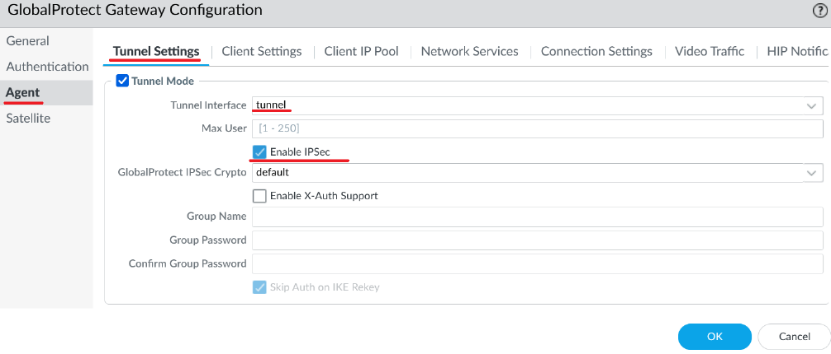
Under agent, tunnel settings, enable IPsec.
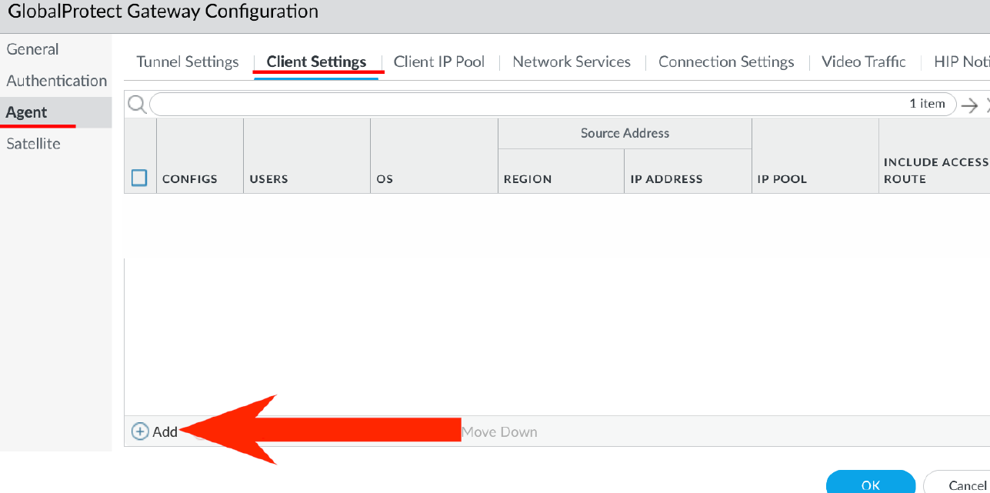
Under client settings, hit add.
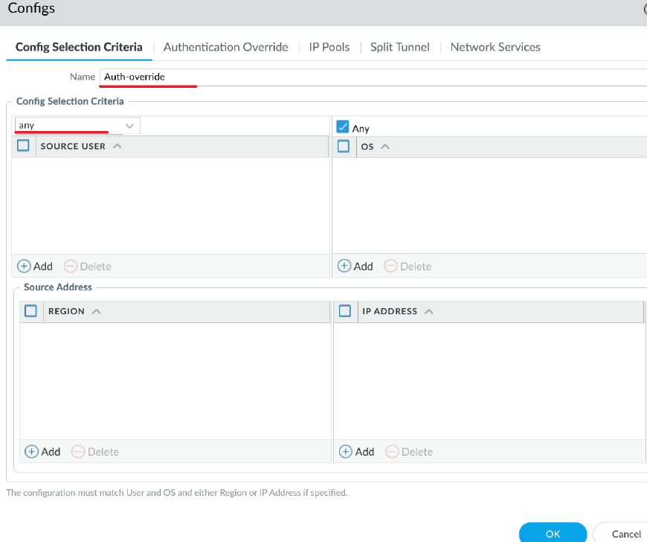
Give appropriate name and set config selection to any.
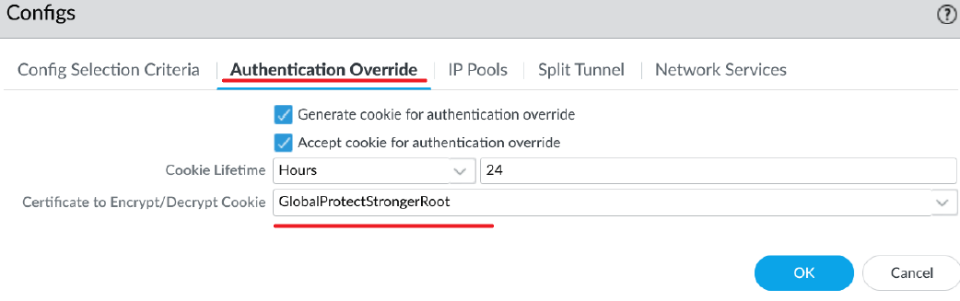
Under authentication override, set the root cert to encrypt/decrypt.
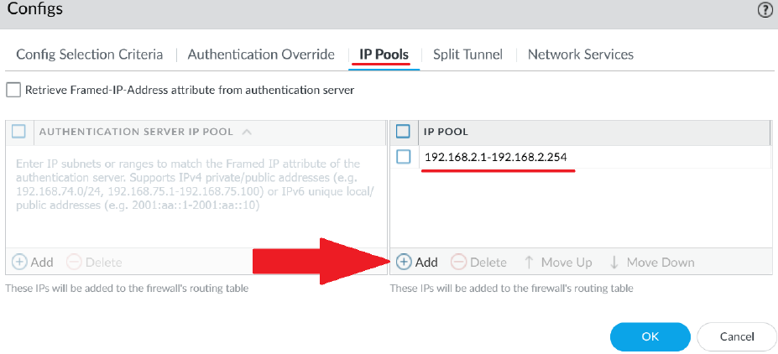
Under IP pools, give the pool a set of ip’s to give to the clients.
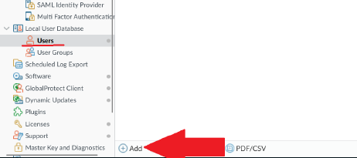
Under device, users, click add.
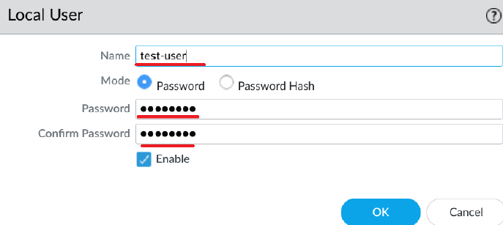
Create a username and password.
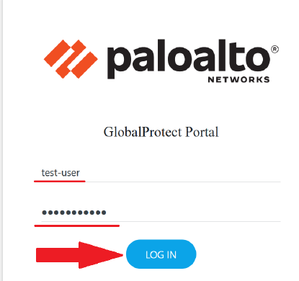
From the web on the outside PC, connect to the outside facing ip of the firewall (ex: 192.168.40.180). Then log in.
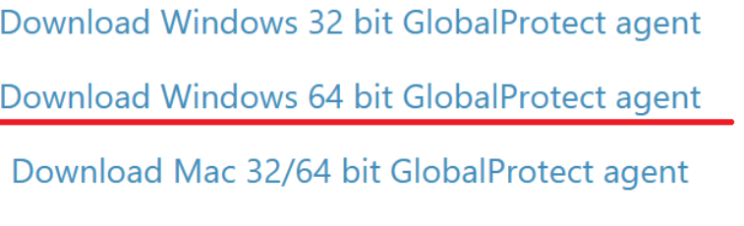
Download the vpn agent for whichever applies to the computer being used and install.
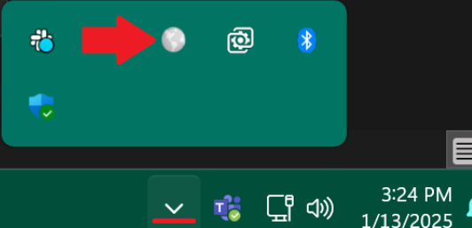
Open the global protect client.
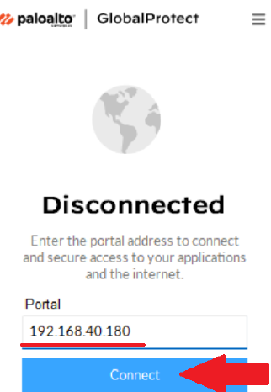
Connect to the outward facing ip of the firewall.
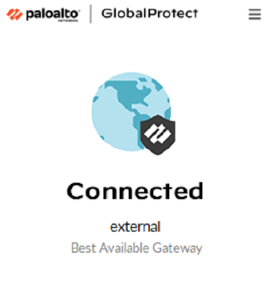

Sign off:


